r-pac International corporation
Global IT Team
EPC Module
customer epc logic and testing scripts
Contents

Centauro 2
Lacoste 4
Inditex 6
State of Art 7
Babyshop 9
C&A 11
Encuentro Moda 13
Kennedy Space Center 15
Moose Knuckles 17
Lindex 19
Diesel 20
MANGO 22
MANGO – Item Code: SSW 24
BlueFields 26
Alvaro Moreno 28
Gerry Weber 30
Stone Island 32
Desigual 34
Charanga 36
TENDAM 38
HugoBoss 40
Walbusch 42
HamiltonBeach 44
Thinx 50
ByerCalifornia 52

Centauro

Schema Type: SGTIN-96
Schema Info: Standard

Serial number start: 1000000.
Serial number end: 0

Serial Prefix:
Prefix length: 7 digits
Prefix Type:

Kill Password: NA
Access Password: NA

User Memory Logic: NA

Json Request & Response
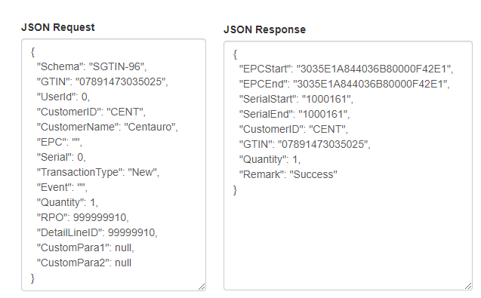

The affected tables are ‘tblEPCSerila’ and ‘tblEPCLog’

EPC Encoder/Decoder tool

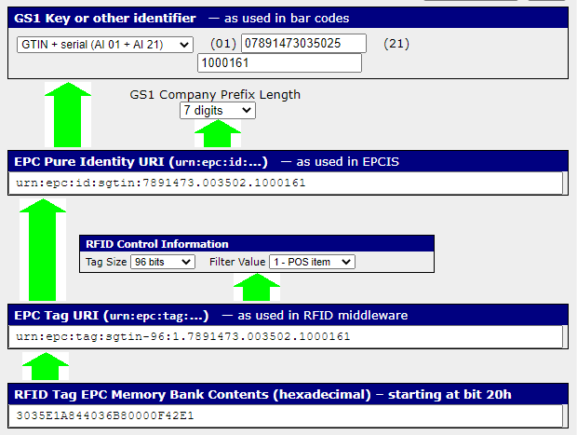

Lacoste

Schema Type: SGTIN-96
Schema Info: Standard

Serial number start: 20000000001.
Serial number end: 0

Serial Prefix:
Prefix length: 7 digits
Prefix Type:

Kill Password: NA
Access Password: NA

User Memory Logic: NA

Json Request & Response

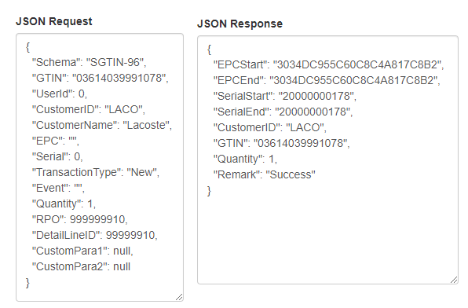

The affected tables are ‘tblEPCSerila’ and ‘tblEPCLog’

EPC Encoder/Decoder tool

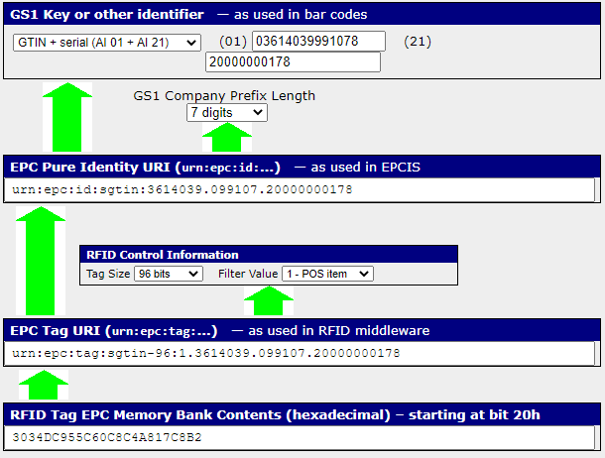

Inditex

Schema Type: SGTIN-96
Schema Info: We are using GTIN "00123456123456" for serial number increment.

Serial number start: 1500000.
Serial number end: 4294967295

Serial Prefix:
Prefix length:
Prefix Type:

Kill Password: 00000000
Access Password: 07F6D645

User Memory Logic: 00B77543

Json Request & Response

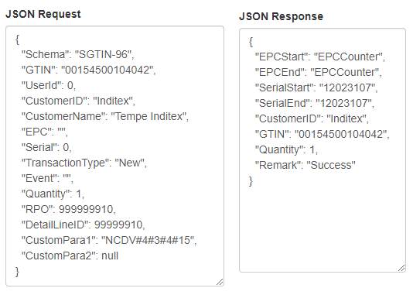

The affected tables are ‘tblEPCSerila’ , ‘tblEPCLog’ and ‘tblEPCCounter’

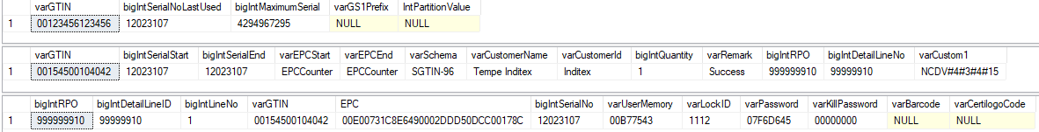

Please note that we are using GTIN "00123456123456" for serial number increment.

State of Art

Schema Type: SGTIN-96
Schema Info: Standard

Serial number start: 100000000000.
Serial number end: 0

Serial Prefix:
Prefix length: 7 digits
Prefix Type:

Kill Password: NA
Access Password: NA

User Memory Logic: NA

Json Request & Response

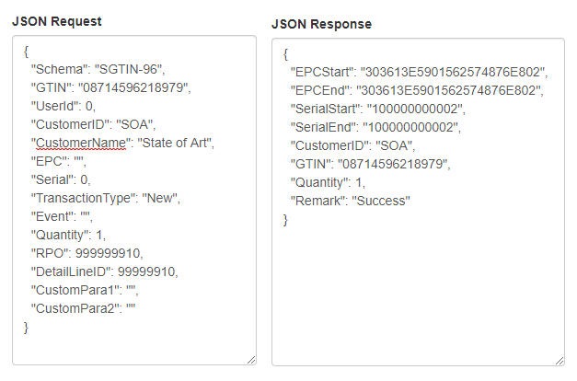

The affected tables are ‘tblEPCSerila’ and ‘tblEPCLog’

EPC Encoder/Decoder tool

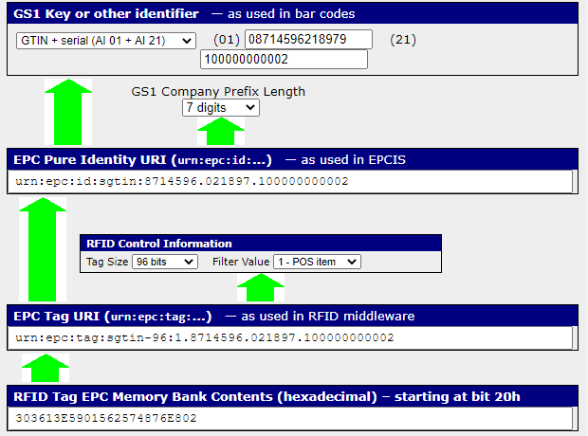

Babyshop

Schema Type: SGTIN-96
Schema Info: Prefix 4 is added to serial number (40000000000).

Serial number start: 0
Serial number end: 0

Serial Prefix: 40000000000
Prefix length: 6 digits
Prefix Type:

Kill Password: NA
Access Password: NA

User Memory Logic: NA

Json Request & Response
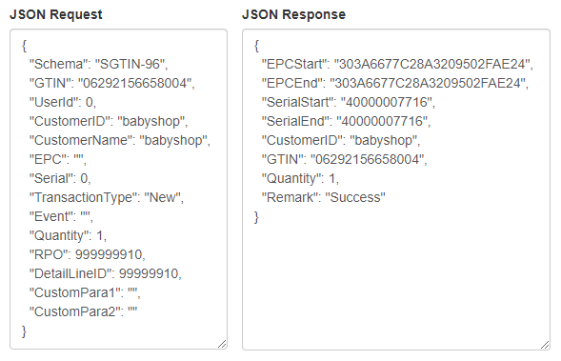

The affected tables are ‘tblEPCSerila’ and ‘tblEPCLog’

EPC Encoder/Decoder tool

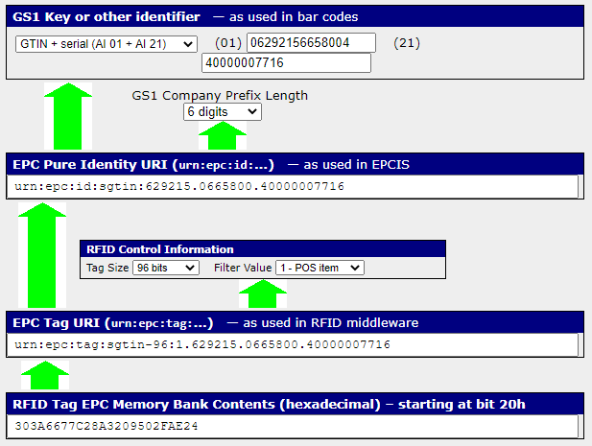

C&A
Schema Type: SGTIN-96
Schema Info: Standard

Serial number start: 8589934592.
Serial number end: 12884901887

Serial Prefix:
Prefix length: 7 digits
Prefix Type:

Kill Password: NA
Access Password: NA

User Memory Logic: NA

Json Request & Response
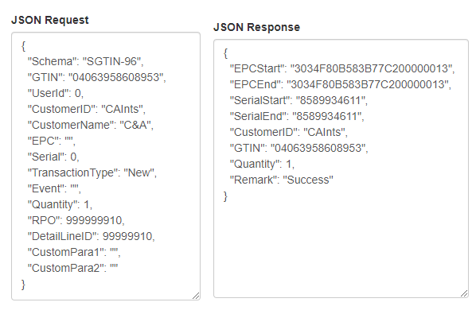

The affected tables are ‘tblEPCSerila’ and ‘tblEPCLog’

EPC Encoder/Decoder tool

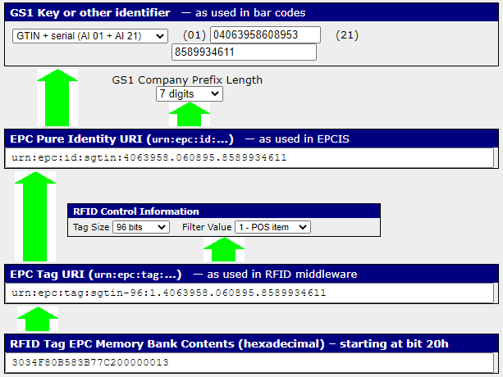

Encuentro Moda

Schema Type: SGTIN-96
Schema Info: Standard

Serial number start: 0
Serial number end: 0

Serial Prefix:
Prefix length: 7 digits
Prefix Type:

Kill Password: E411F96B
Access Password: 270C3E2F

User Memory Logic: 00000094

Json Request & Response
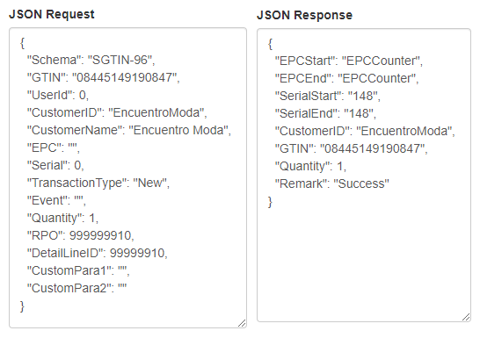

The affected tables are ‘tblEPCSerila’ , ‘tblEPCLog’ and ‘tblEPCCounter’

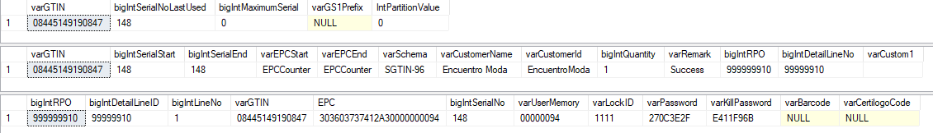

EPC Encoder/Decoder tool

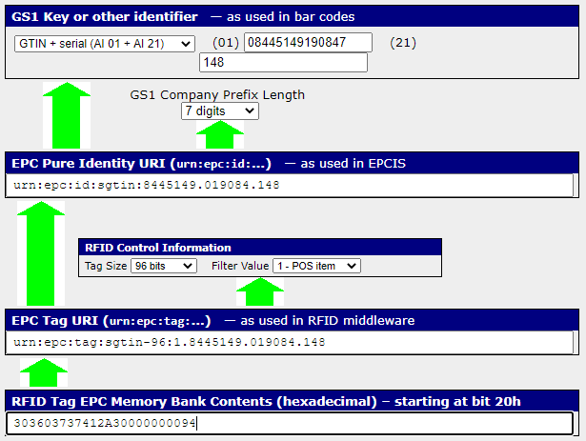

Kennedy Space Center

Schema Type: SGTIN-96
Schema Info: Standard

Serial number start: 0
Serial number end: 0

Serial Prefix:
Prefix length: 7 digits
Prefix Type:

Kill Password: NA
Access Password: NA

User Memory Logic: NA

Json Request & Response
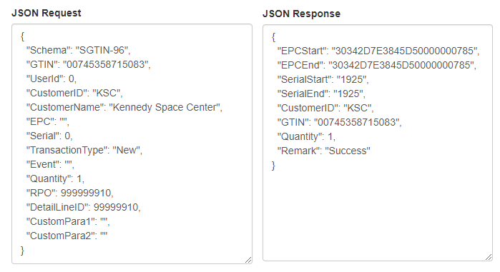

The affected tables are ‘tblEPCSerila’ and ‘tblEPCLog’

EPC Encoder/Decoder tool

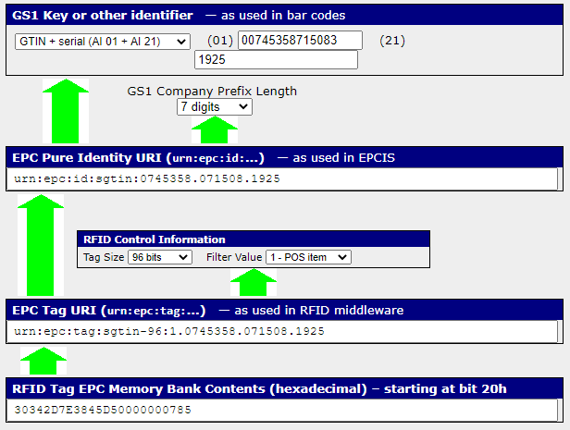

Moose Knuckles

Schema Type: SGTIN-96
Schema Info: Standard

Serial number start: 1000000
Serial number end: 0

Serial Prefix:
Prefix length: 7 digits
Prefix Type:

Kill Password: NA
Access Password: NA

User Memory Logic: NA

Json Request & Response
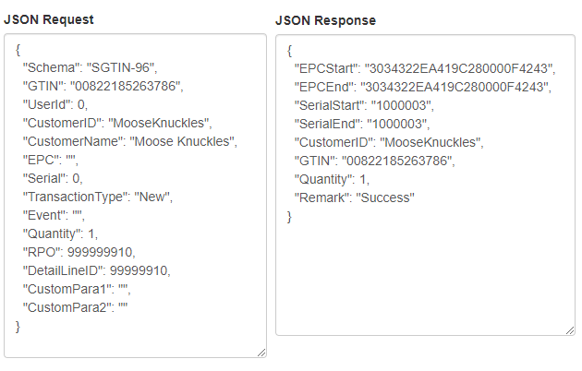

The affected tables are ‘tblEPCSerila’ and ‘tblEPCLog’

EPC Encoder/Decoder tool

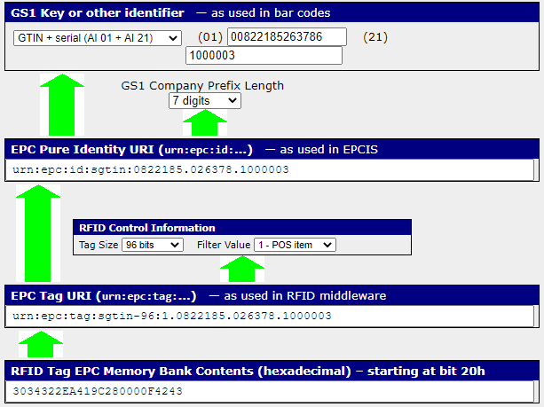

Lindex

Schema Type: SGTIN-96
Schema Info: We do not make any type of EPC. Only maintain serial number

Serial number start: 0
Serial number end: 9999999

Serial Prefix:
Prefix length:
Prefix Type:

Kill Password: NA
Access Password: NA

User Memory Logic: NA

Json Request & Response

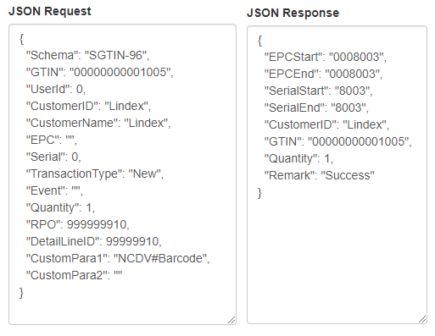

The affected tables are ‘tblEPCSerila’ and ‘tblEPCLog’

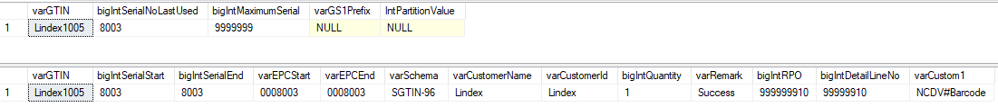

Diesel

Schema Type: SGTIN-96
Schema Info: Standard

Serial number start: 0
Serial number end: 0

Serial Prefix:
Prefix length: 7 digits
Prefix Type:

Kill Password: AB161A94
Access Password: EEDF1E78

User Memory Logic: 00000008

Json Request & Response
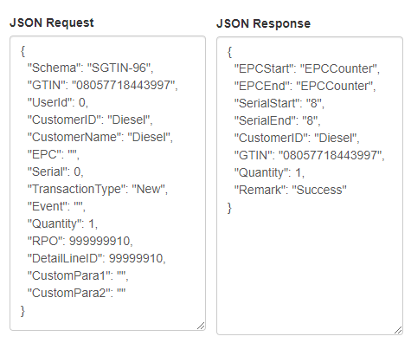

The affected tables are ‘tblEPCSerila’ , ‘tblEPCLog’ and ‘tblEPCCounter’

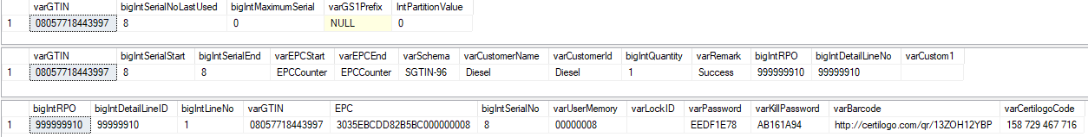

EPC Encoder/Decoder tool

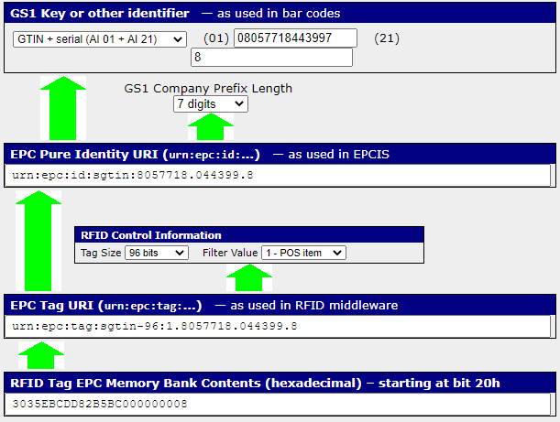

MANGO

Schema Type: SGTIN-96
Schema Info: Standard

Serial number start: 17280532480
Serial number end: 17314086911

Serial Prefix:
Prefix length: Partition value is determined by making a call to the GS1 database to determine the company prefix length.
Prefix Type:

Kill Password: 88CF63EA
Access Password: C823FF44

User Memory Logic: NA

Json Request & Response
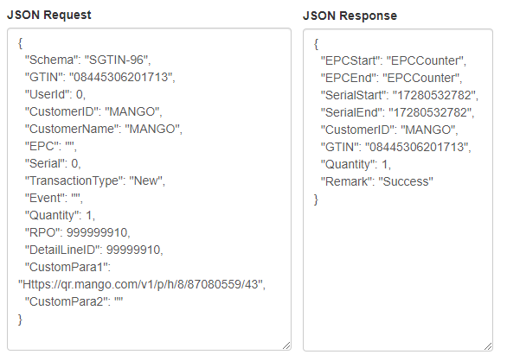
The affected tables are ‘tblEPCSerila’ , ‘tblEPCLog’,‘tblEPCCounter’ and ‘tblGS1CustomerDetail’

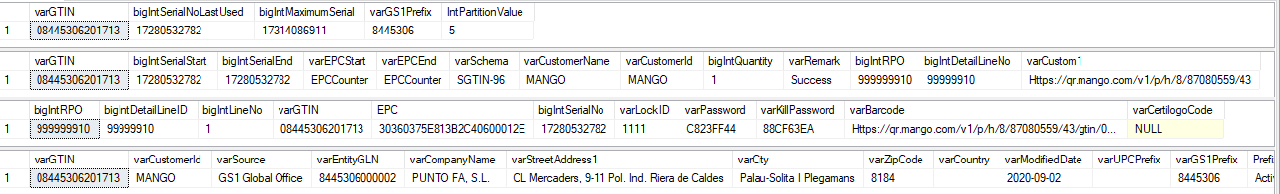

EPC Encoder/Decoder tool

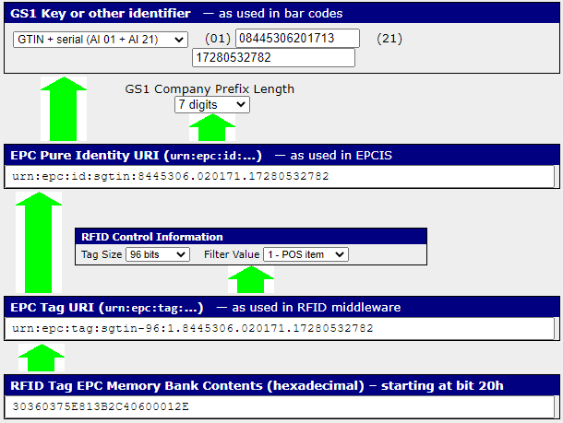

MANGO – Item Code: SSW

Schema Type: SGTIN-96
Schema Info: Standard

Serial number start: 51640270849
Serial number end: 51673825279

Serial Prefix:
Prefix length: 7 digits
Prefix Type:

Kill Password: NA
Access Password: NA

User Memory Logic: NA

Json Request & Response
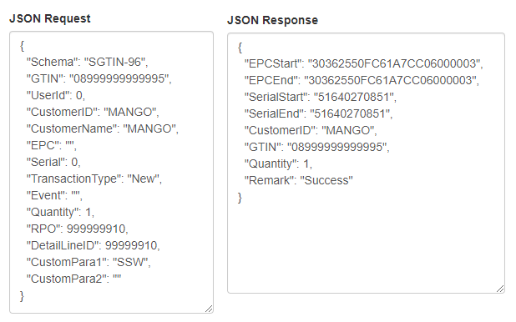

The affected tables are ‘tblEPCSerila’ , ‘tblEPCLog’ and ‘tblGS1CustomerDetail’

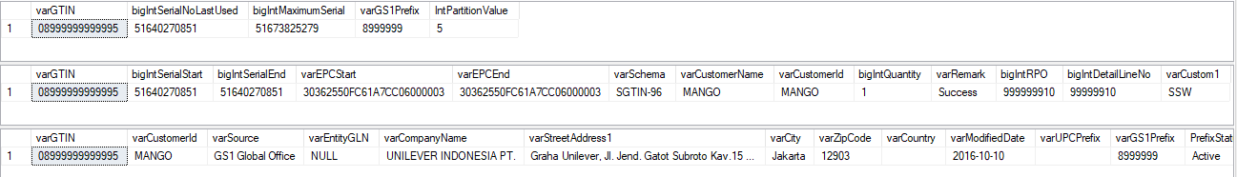

EPC Encoder/Decoder tool

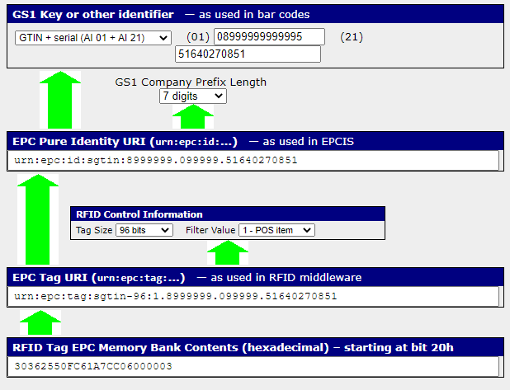

BlueFields

Schema Type: SGTIN-96
Schema Info: Standard

Serial number start: 100000000000
Serial number end: 0

Serial Prefix:
Prefix length: 7 digits
Prefix Type:

Kill Password: NA
Access Password: NA

User Memory Logic: NA

Json Request & Response
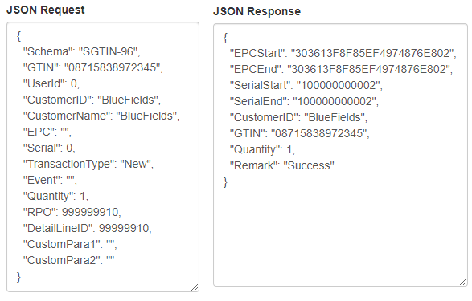

The affected tables are ‘tblEPCSerila’ and ‘tblEPCLog’

EPC Encoder/Decoder tool

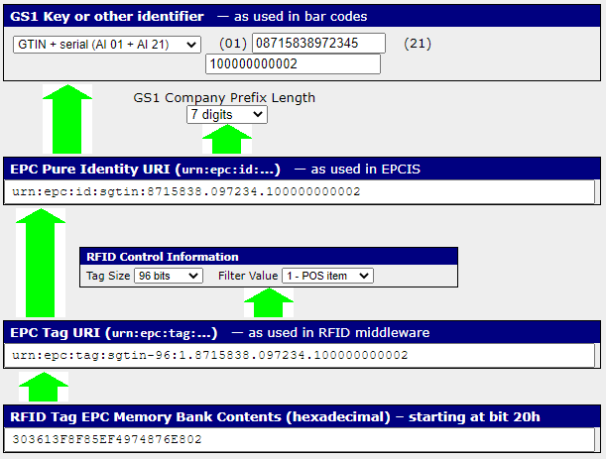

Alvaro Moreno

Schema Type: SGTIN-96
Schema Info: Standard

Serial number start: 1
Serial number end: 0

Serial Prefix:
Prefix length: Partition value is determined by making a call to the GS1 database to determine the company prefix length.
Prefix Type:

Kill Password: EF83DA4D
Access Password: D8B0A01F

User Memory Logic: NA

Json Request & Response
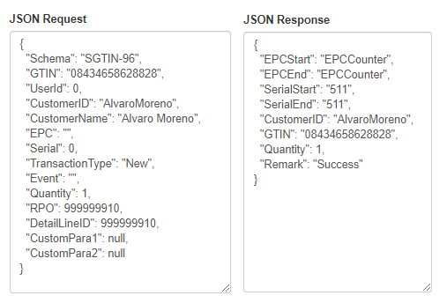
The affected tables are ‘tblEPCSerila’ , ‘tblEPCLog’,‘tblEPCCounter’ and ‘tblGS1CustomerDetail’

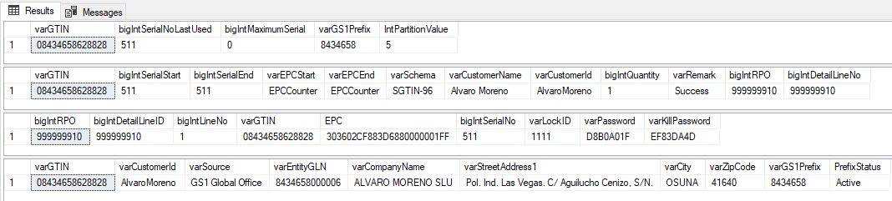

EPC Encoder/Decoder tool
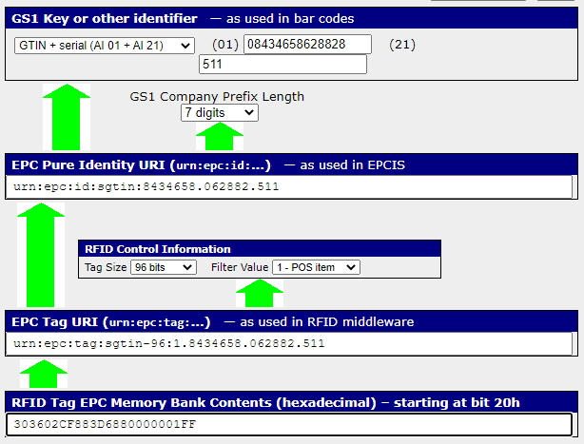

Gerry Weber

Schema Type: SGTIN-96
Schema Info: Standard

Serial number start: 1255103
Serial number end: 0

Serial Prefix:
Prefix length: 7 digits
Prefix Type:

Kill Password: NA
Access Password: NA

User Memory Logic: NA

Json Request & Response
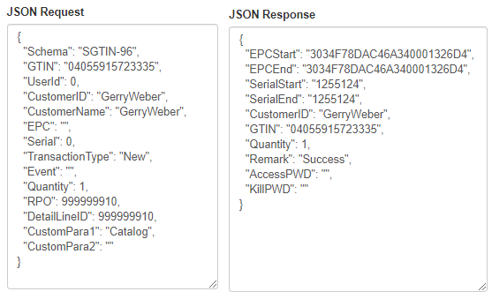
The affected tables are ‘tblEPCSerila’ , ‘tblEPCLog’

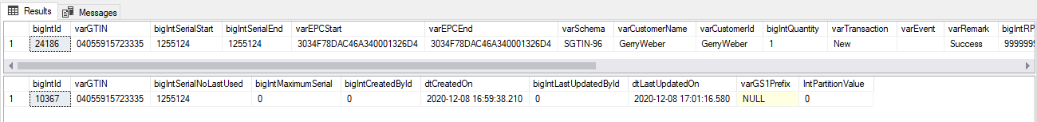

EPC Encoder/Decoder tool

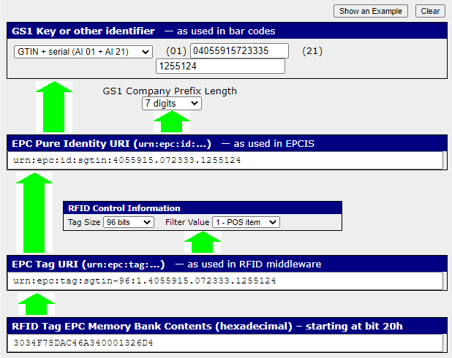

Stone Island

Schema Type: SGTIN-96
Schema Info: Standard

Serial number start: 0
Serial number end: 0

Serial Prefix:
Prefix length: 7 digits
Prefix Type:

Kill Password: NA
Access Password: NA

User Memory Logic: NA

Json Request & Response
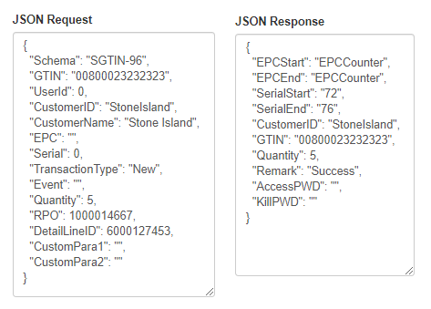
The affected tables are ‘tblEPCSerila’ , ‘tblEPCLog’ and ‘tblEPCCounter’

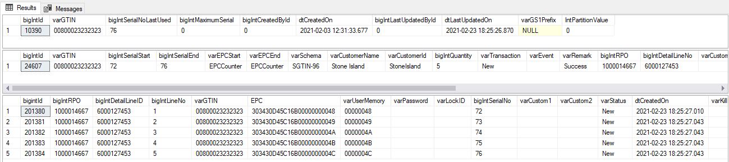

EPC Encoder/Decoder tool
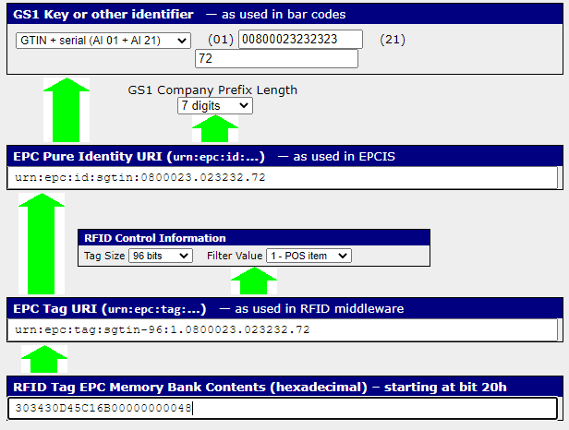

Desigual

Schema Type: SGTIN-96
Schema Info: Standard

Serial number start: 230000001
Serial number end: 235000000

Serial Prefix:
Prefix length: 7 digits
Prefix Type:

Kill Password: NA
Access Password: NA

User Memory Logic: NA

Json Request & Response
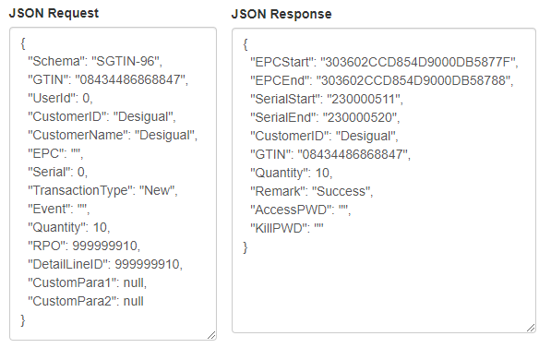

The affected tables are ‘tblEPCSerila’ , ‘tblEPCLog’

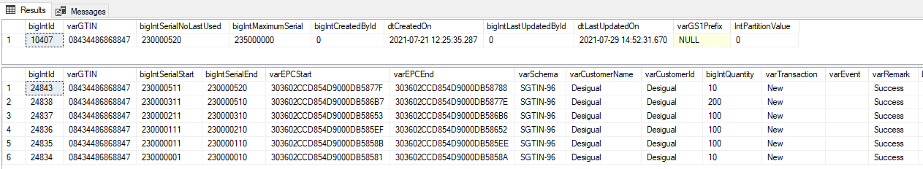

EPC Encoder/Decoder tool

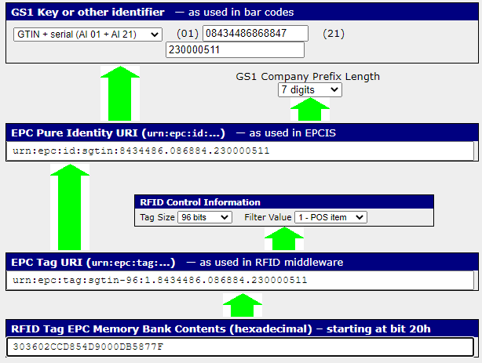

Charanga

Schema Type: SGTIN-96
Schema Info: Standard

Serial number start: 1
Serial number end: 0

Serial Prefix:
Prefix length: Partition value is determined by making a call to the GS1 database to determine the company prefix length.
Prefix Type:

Kill Password: 25193528
Access Password: 25193528

User Memory Logic: NA

Json Request & Response
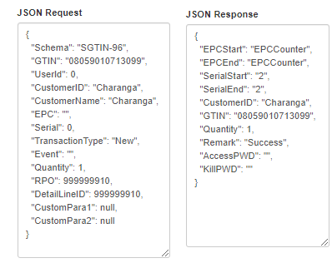

The affected tables are ‘tblEPCSerila’, ‘tblEPCLog’ , ‘tblEPCCounter’ and ‘tblGS1CustomerDetail’

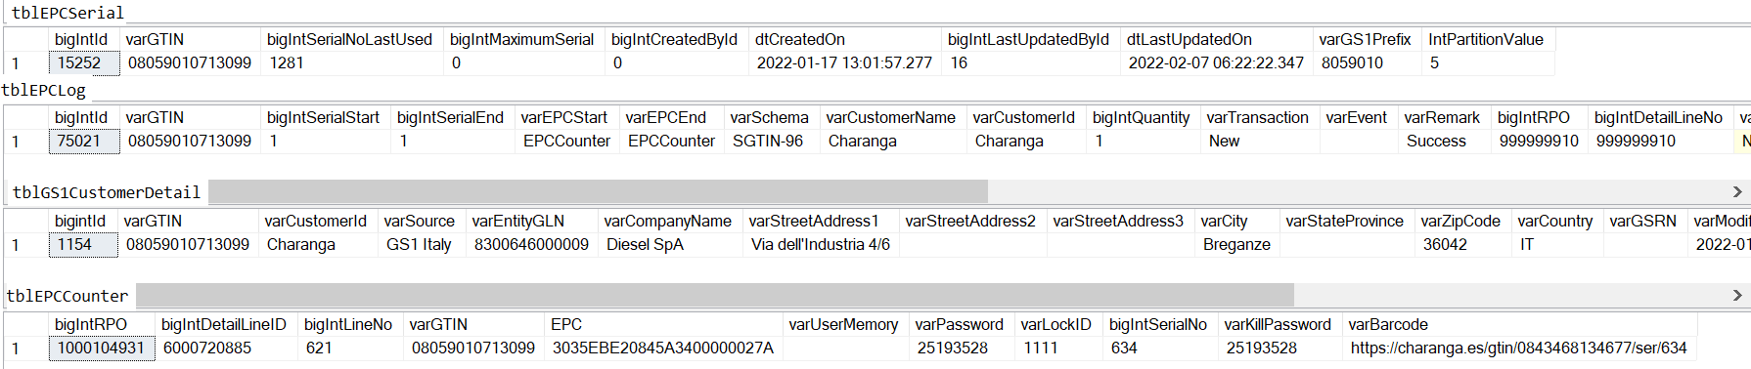
EPC Encoder/Decoder tool

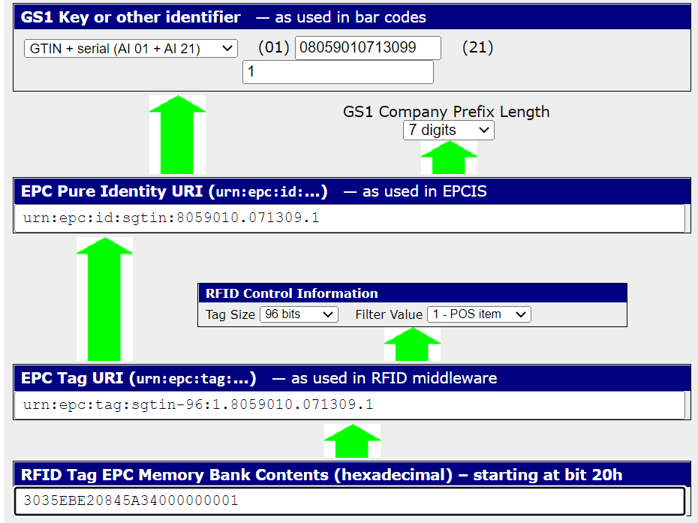

TENDAM

Schema Type: SGTIN-96
Schema Info: Standard

Serial number start: 60,000,001
Serial number end: 69,999,999

Serial Prefix:
Prefix length: Partition value is determined by making a call to the GS1 database to determine the company prefix length.

Prefix Type:

Kill Password: 4723396B
Access Password: 4723396B

User Memory Logic: NA

Json Request & Response
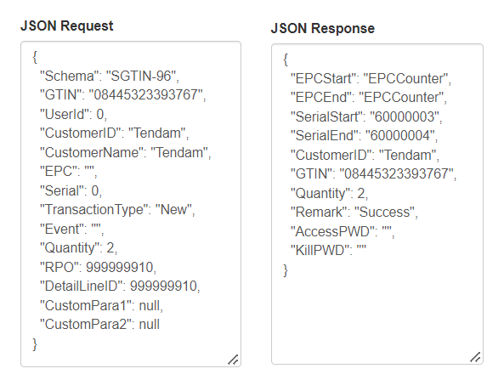

The affected tables are ‘tblEPCSerila’, ‘tblEPCLog’ , ‘tblEPCCounter’ and ‘tblGS1CustomerDetail’

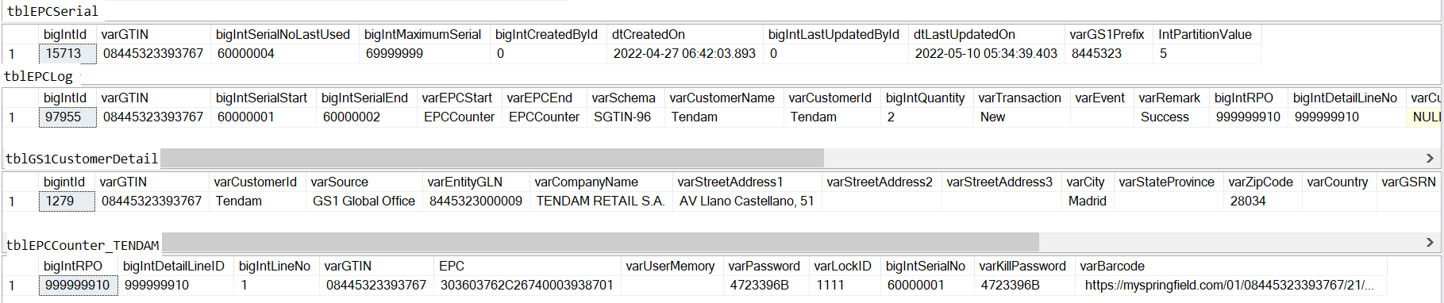
EPC Encoder/Decoder tool

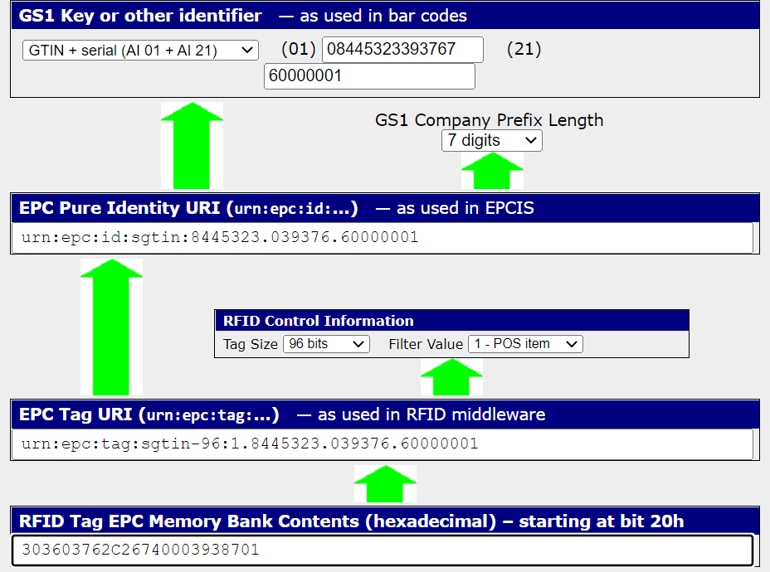

HugoBoss

Schema Type: SGTIN-96
Schema Info: We are using GTIN " 04021407000000" for serial number increment.

Serial number start: 1
Serial number end: 68719476735

Serial Prefix:
Prefix length: 7 digits
Prefix Type:

Kill Password: NA
Access Password: NA

User Memory Logic: NA

Json Request & Response
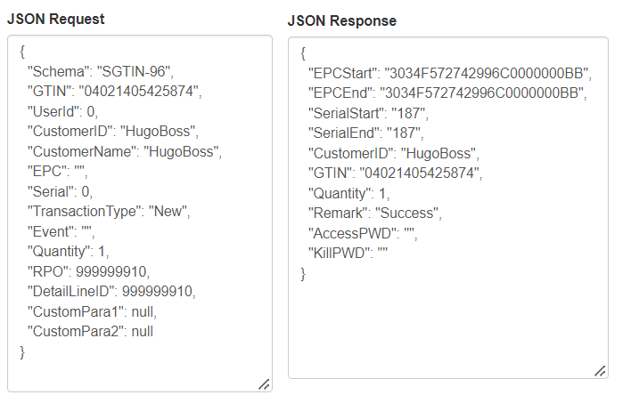

The affected tables are ‘tblEPCSerila’, ‘tblEPCLog’
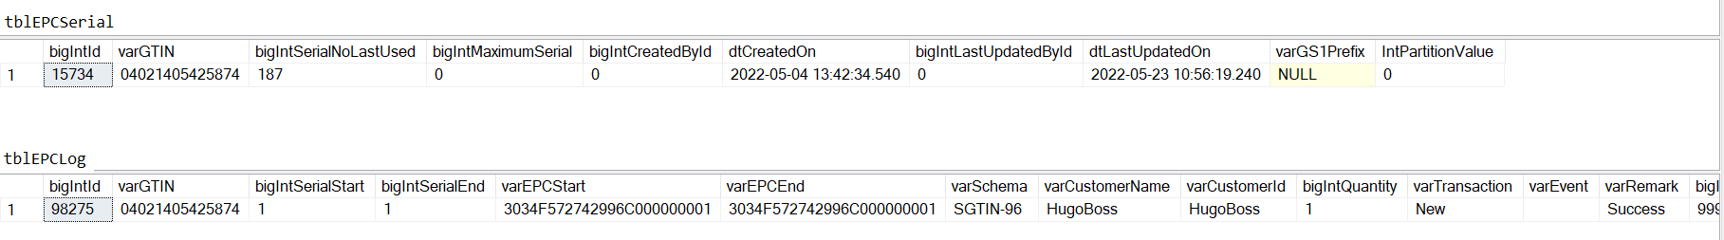

EPC Encoder/Decoder tool

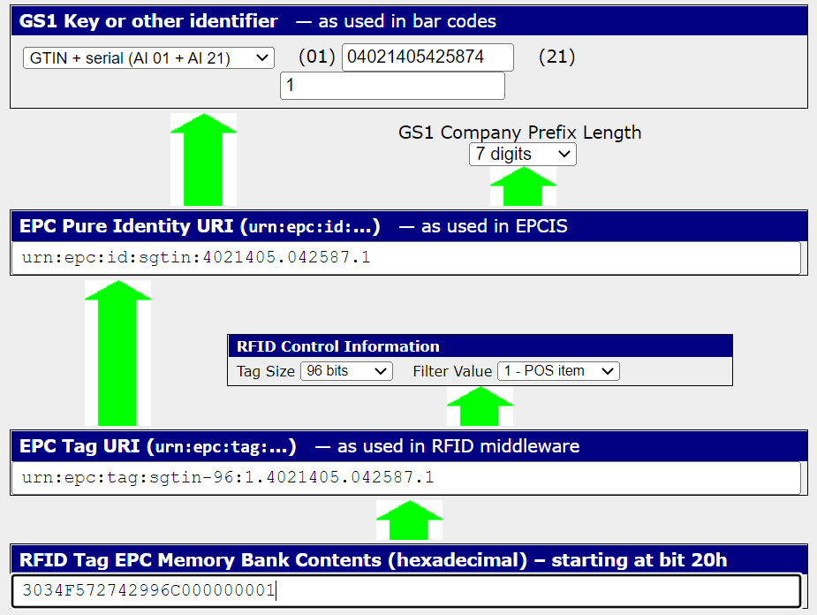

Walbusch

Schema Type: SGTIN-96
Schema Info: Standard

Serial number start: 1
Serial number end: 0

Serial Prefix:
Prefix length: 7 digits
Prefix Type:

Kill Password: NA
Access Password: NA

User Memory Logic: NA

Json Request & Response
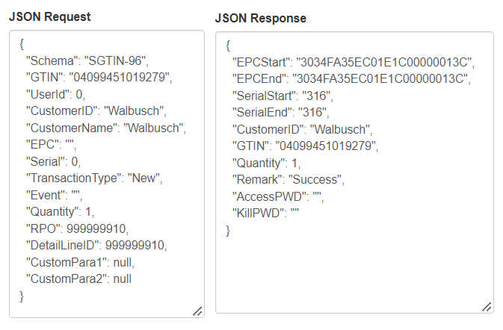

The affected tables are ‘tblEPCSerila’, ‘tblEPCLog’
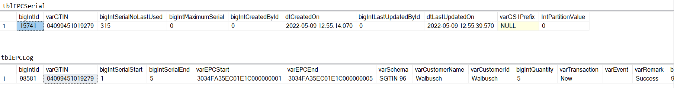

EPC Encoder/Decoder tool

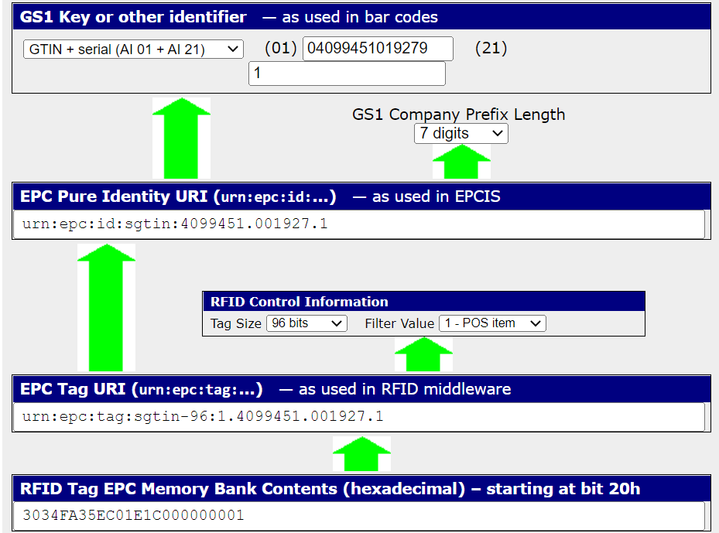

Hamilton Beach

Schema Type: SGTIN-96
Schema Info: Standard

We have 3 types of serial numbers. Please see below for details.

12 digits decimal serial number
- 3 digits for retailer prefix o Retailer is determined by the brand table under master
- 2 digits for model identifier o This is determined from the data feed o Append “0” if only one digit is received
- 7 digits for serial number Walmart National Brand Schema

- Walmart National Brand Schema

# of digits | Value | Comment
3 digits | Retailer prefix | 000
2 digits | Model Identifier | Received in the data feed under “Model Identifier” column, append “0” if only one digit is received
7 digits | Serial Number (max serial number per GTIN will be 9999999) | Serial numbers are generated by us starting from 0700000

Example: 000040700001
Retailer Prefix → 000
Model Identifier → 04
Serial Number → 0700001

- Walmart Private Brand Schema

# of digits | Value | Comment
3 digits | Retailer prefix | 098
2 digits | Model Identifier | Received in the data feed under “Model Identifier” column, append “0” if only one digit is received
7 digits | Serial Number (max serial number per GTIN will be 9999999) | Serial numbers are generated by us starting from 0700000

Example: 098040700001
Retailer Prefix → 098
Model Identifier → 04
Serial Number → 0700001

- Belk National Brand Schema

# of digits | Value | Comment
3 digits | Retailer prefix | 000
2 digits | Model Identifier | Received in the data feed under “Model Identifier” column, append “0” if only one digit is received
7 digits | Serial Number (max serial number per GTIN will be 9999999) | Serial numbers are generated by us starting from 0000001

Example: 000040000001
Retailer Prefix → 000
Model Identifier → 04
Serial Number → 0000001

Serial Prefix:
Prefix length: Partition value is determined by making a call to the GS1 database to determine the company prefix length.
Prefix Type:

Kill Password: NA
Access Password: NA

User Memory Logic: NA

Json Request & Response (Walmart National Brand Schema)
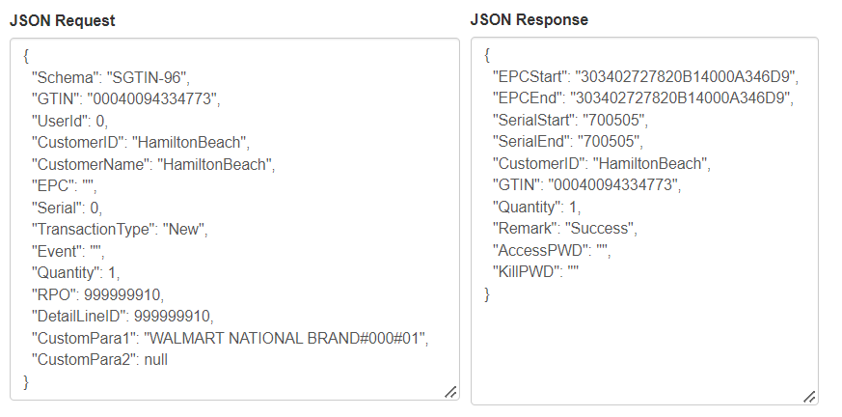
EPC Encoder/Decoder tool (Walmart National Brand Schema)

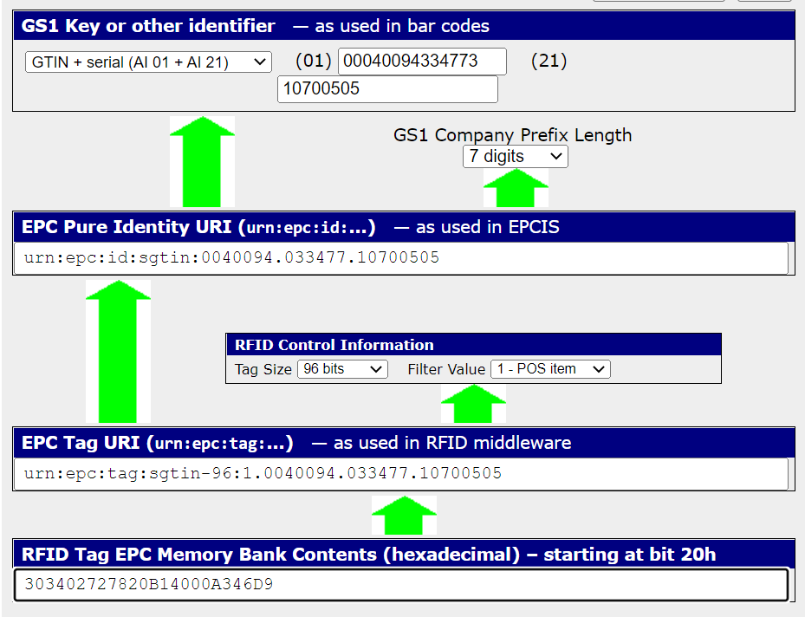

Json Request & Response (Walmart Private Brand Schema)
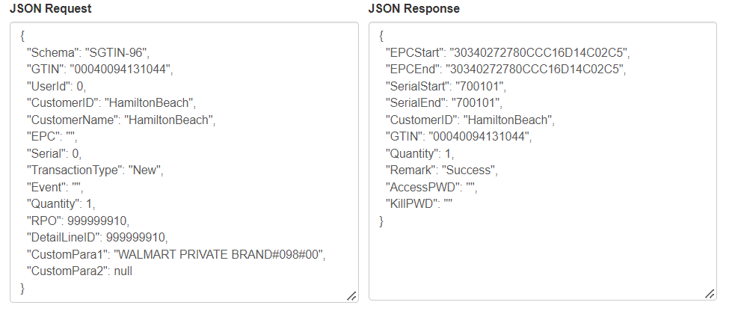
EPC Encoder/Decoder tool (Walmart Private Brand Schema)

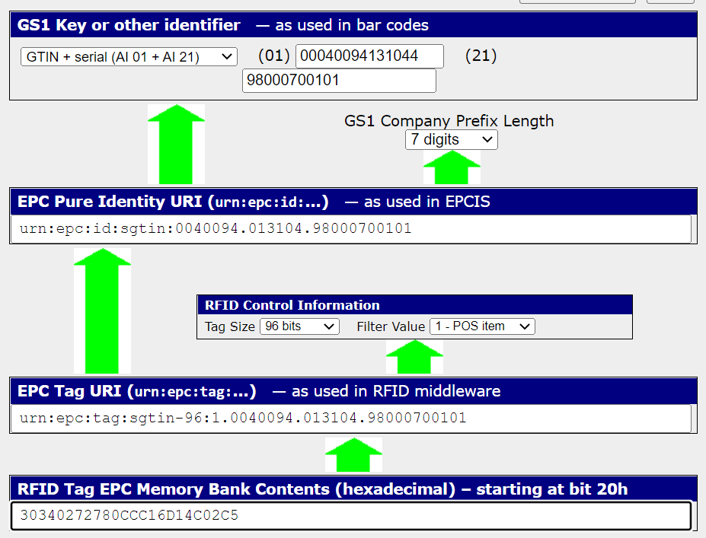

Json Request & Response (Belk National Brand Schema)
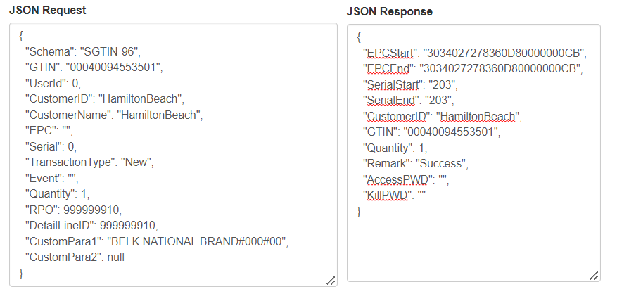
EPC Encoder/Decoder tool (Belk National Brand Schema)

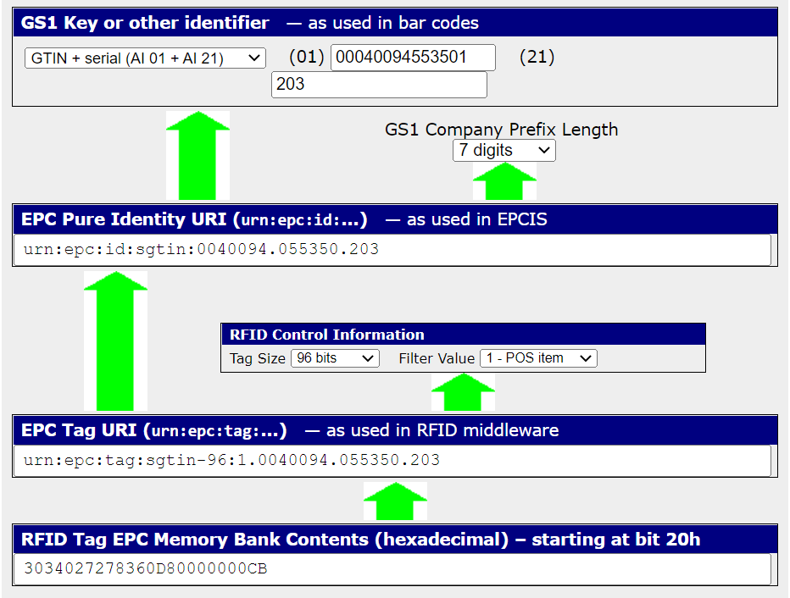

The affected tables are ‘tblGS1CustomerDetail’ ‘tblEPCSerila’, ‘tblEPCLog’

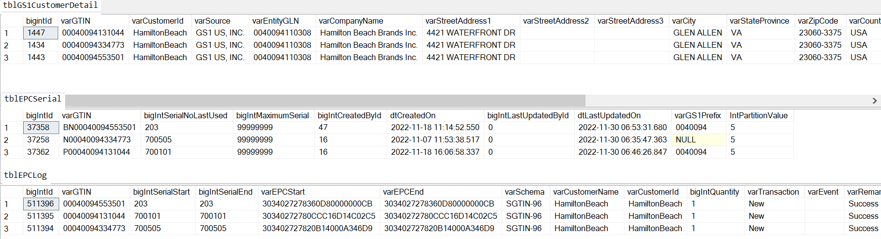

THINX

Schema Type: SGTIN-96
Schema Info: Standard

Serial number start: 015001000000
Serial number end: 015999999999

Serial Prefix:
Prefix length: Partition value is determined by making a call to the GS1 database to determine the company prefix length.
Prefix Type:

Kill Password: NA
Access Password: NA

User Memory Logic: NA

Json Request & Response

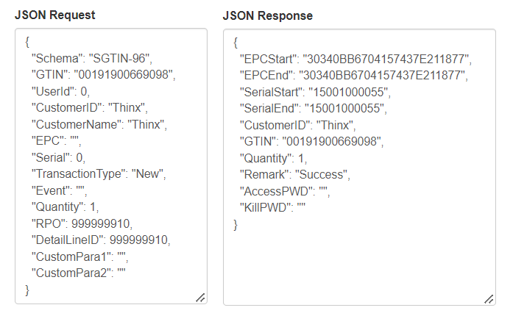

The affected tables are ‘tblGS1CustomerDetail’, ‘tblEPCSerila’ and ‘tblEPCLog’

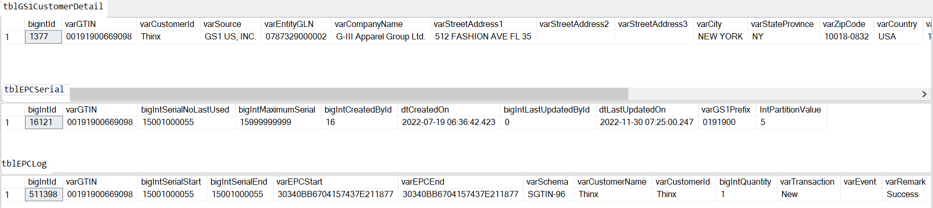

EPC Encoder/Decoder tool

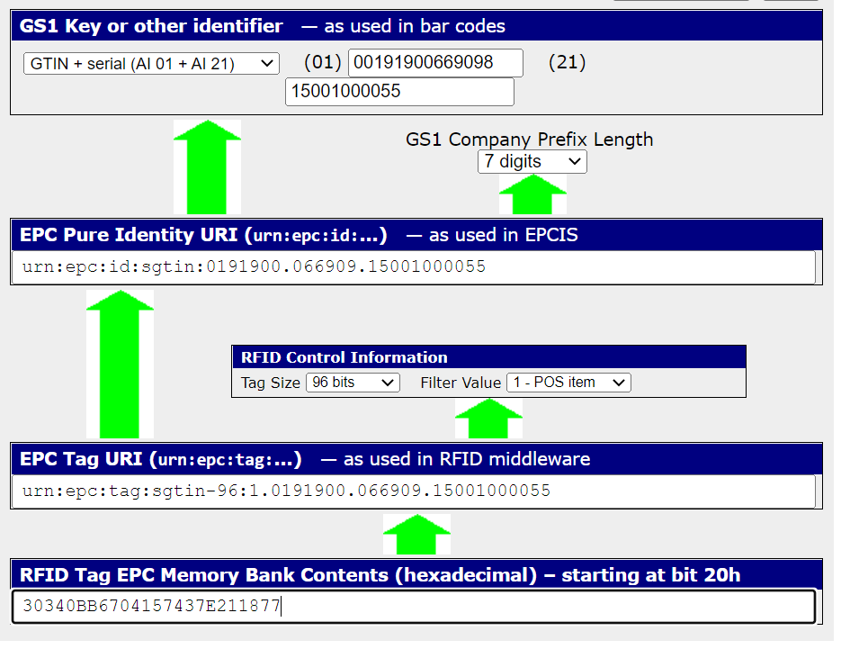

ByerCalifornia

Schema Type: SGTIN-96
Schema Info: Standard

Serial number start: 0
Serial number end: NA

Serial Prefix:
Prefix length: Partition value is determined by making a call to the GS1 database to determine the company prefix length.
Prefix Type:

Kill Password: NA
Access Password: NA

User Memory Logic: NA

Json Request & Response

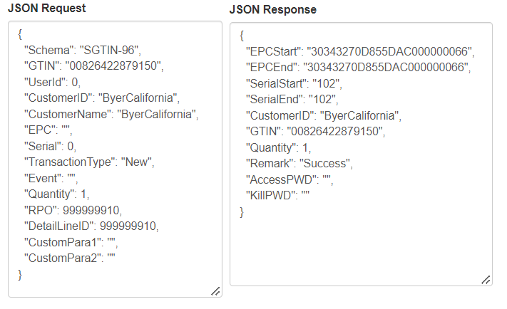

The affected tables are ‘tblGS1CustomerDetail’, ‘tblEPCSerila’ and ‘tblEPCLog’

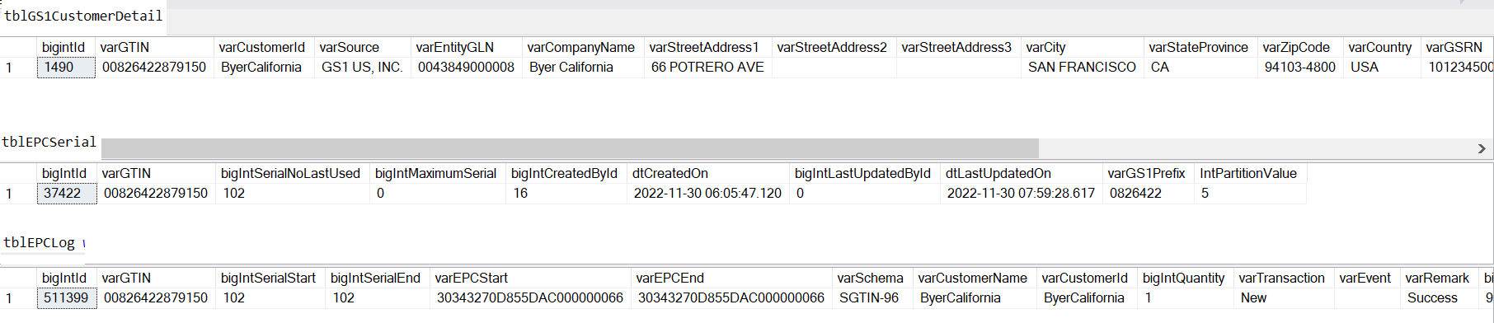

EPC Encoder/Decoder tool

